Implement hard links in Linux
Introduction
In this challenge, you will explore the concept of hard links in a Linux file system. You'll create hard links and modify file content, observing how these actions affect file attributes.
Environment
LabEx uses Red Hat Universal Base Image 9 (UBI9) to simulate the exam environment. It may not be identical to the actual RHCSA exam environment, but it provides a good representation of the tasks you'll encounter.
There are two users in the environment:
- labex: A standard user with sudo privileges, password: labex.
- root: The system administrator, password: redhat.
The challenge features real exam questions, along with explanations, requirements, and automated verification scripts to help you confirm task completion. It effectively simulates the knowledge areas covered in the RHCSA exam.

Creating and Manipulating Hard Links
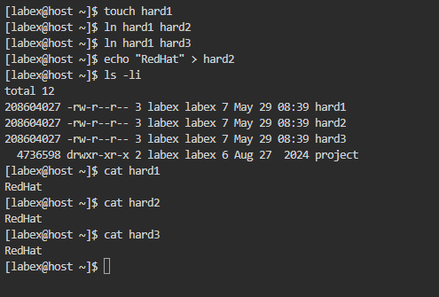
Tasks
Create an empty file named hard1
Create two hard links to hard1: hard2 and hard3
Add content to hard2
Requirements
All files must be created in the /home/labex directory
Create hard1 using the touch command
Create hard2 and hard3 using the ln command
Add the content "Redhat" to /home/labex/hard2
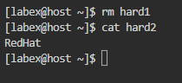
Use ls -li to display file attributes of all three files
The number at the beginning is the inode number, which will be the same for all hard links to the same file. Note that the link count is 3 for all files.
Notes:
ln is a Linux command used to create links between files.
- Hard link: ln file1 file2
  - Creates another name for the same file.
- Soft (symbolic) link: ln -s file1 file2
  - Creates a shortcut pointing to the original file.
What is an Inode?
Think of an inode as a file's unique ID card in Linux.
When you create a file, Linux stores:
- File permissions
- Owner
- File size
- Creation/modification times
- Location of data on disk
inside an inode.
The filename itself is stored separately and points to that inode.
Summary
In this challenge, you explored hard links in a Linux file system. You created multiple hard links to the same file, observed how they share the same inode number, and how modifying one link affects all others. This exercise demonstrated the relationship between inodes, hard links, and file content in a Linux file system. Understanding these concepts is crucial for effective file management and storage in Linux environments, especially when dealing with file systems, backups, and data organization.
Log in and Switch user
Introduction
In Linux systems, it's common to have multiple users sharing the same environment. As a system administrator, you need to be proficient in managing user accounts and switching between them. This challenge will test your skills in user management and authentication in a Linux environment.
Environment
LabEx uses Red Hat Universal Base Image 9 (UBI9) to simulate the exam environment. It may not be identical to the actual RHCSA exam environment, but it provides a good representation of the tasks you'll encounter.
There are two users in the environment:
- labex: A standard user with sudo privileges, password: labex.
- root: The system administrator, password: redhat.
The challenge features real exam questions, along with explanations, requirements, and automated verification scripts to help you confirm task completion. It effectively simulates the knowledge areas covered in the RHCSA exam.
Switch Users and Create a New Account
This step will guide you through the process of switching between users and creating a new user account.
Tasks
Switch to the root user using sudo (sudo -i or sudo su)
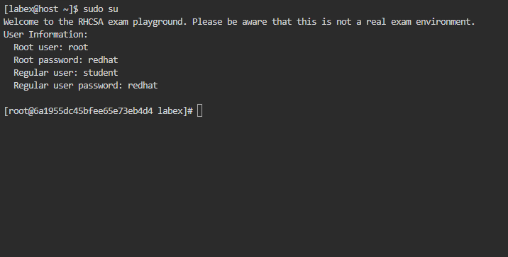
Create a new user named anamika
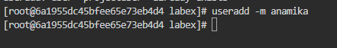
Switch to the anamika account
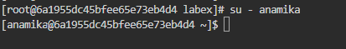
Return to the labex user account
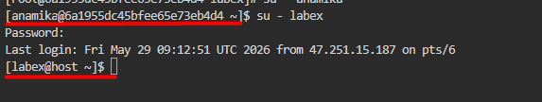
Requirements
You are already logged in as the labex user
All operations should be performed in the terminal
Use the sudo command to switch to the root user
Create the projectuser with a home directory in /home/projectuser
Set the password for projectuser to project123
Use the su command to switch between users
Ensure you end up logged in as the labex user
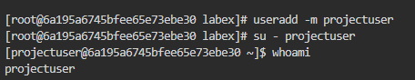
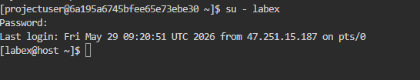
Summary
In this challenge, you practiced essential user management skills in a Linux environment. You learned how to switch between users using sudo and su commands, create a new user account with a specified home directory, and set user passwords. These skills are crucial for system administrators managing multi-user systems, ensuring proper user isolation, and maintaining system security.
Manage File permission
Introduction
In Linux systems, file permissions are crucial for controlling access to files and directories. This challenge will test your ability to manipulate file permissions using the chmod command, which is an essential skill for system administrators and Linux users.
Environment
LabEx uses Red Hat Universal Base Image 9 (UBI9) to simulate the exam environment. It may not be identical to the actual RHCSA exam environment, but it provides a good representation of the tasks you'll encounter.
There are two users in the environment:
- labex: A standard user with sudo privileges, password: labex.
- root: The system administrator, password: redhat.
- 7 (owner) = read + write + execute
- 5 (group) = read + execute
- 5 (others) = read + execute
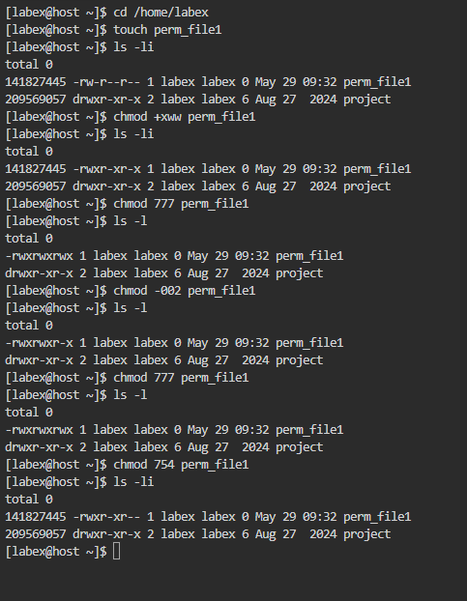
Create and Extract Tar Archives
Introduction
In this challenge, you will create compressed tar archives of the /home directory using both gzip and bzip2 compression methods, and then extract them. This skill is essential for system administrators who need to efficiently backup and transfer large amounts of data.
Environment
LabEx uses Red Hat Universal Base Image 9 (UBI9) to simulate the exam environment. It may not be identical to the actual RHCSA exam environment, but it provides a good representation of the tasks you'll encounter.
There are two users in the environment:
labex: A standard user with sudo privileges, password: labex.
root: The system administrator, password: redhat.
Create and Extract Compressed tar Archives
Tasks
Create gzip and bzip2 compressed tar archives of the /home directory
List the contents of both archives
Extract both archives
Requirements
Perform all operations in the /home/labex directory
Create the following archives:
Gzip-compressed: /home/labex/home.tar.gz
Bzip2-compressed: /home/labex/home.tar.bz2
List the contents of both archives in /home/labex
Extract both archives to /home/labex/extracted
Use the tar command with appropriate options for all operations.
Step 1: Go to the working directory
cd /home/labex

Step 2: Create a Gzip-compressed archive
tar -czvf home.tar.gz /home
Options:
- c = create
- z = gzip compression
- v = verbose
- f = archive filename
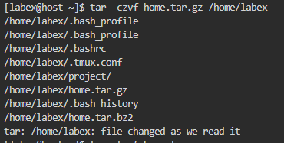

Step 3: Create a Bzip2-compressed archive
tar -cjvf home.tar.bz2 /home
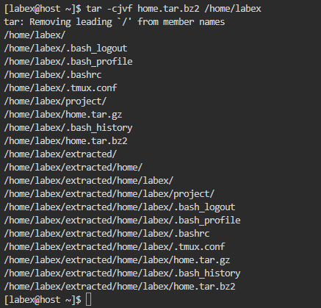

Options:
- j = bzip2 compression

Step 4: List contents of the Gzip archive
tar -tzvf home.tar.gz

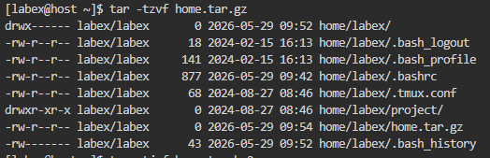

Step 5: List contents of the Bzip2 archive
tar -tjvf home.tar.bz2
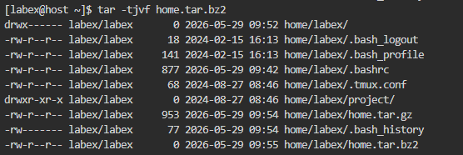
Step 6: Create extraction directory
mkdir -p extracted

Step 7: Extract the Gzip archive
tar -xzvf home.tar.gz -C extracted
Options:
- x = extract
- C = extract to specified directory
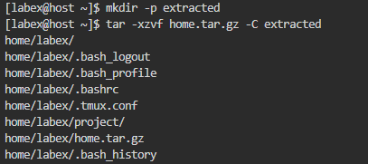

Step 8: Extract the Bzip2 archive
tar -xjvf home.tar.bz2 -C extracted
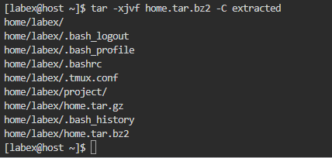

Quick Interview Notes
Command | Purpose
tar -czvf file.tar.gz dir | Create gzip archive
tar -cjvf file.tar.bz2 dir | Create bzip2 archive
tar -tzvf file.tar.gz | List gzip archive contents
tar -tjvf file.tar.bz2 | List bzip2 archive contents
tar -xzvf file.tar.gz | Extract gzip archive
tar -xjvf file.tar.bz2 | Extract bzip2 archive
Easy Memory Trick
- z = gzip
- j = bzip2
- c = create
- t = list
- x = extract
- v = verbose
- f = file

Manage Logs and Archives
Introduction
In this challenge, you will practice essential system administration skills related to log analysis and file archiving. You'll search for specific entries in a simulated log file, export them, and then create an archive of a directory. These tasks simulate common system administration activities for troubleshooting and backup purposes.
Environment
LabEx uses Red Hat Universal Base Image 9 (UBI9) to simulate the exam environment. It may not be identical to the actual RHCSA exam environment, but it provides a good representation of the tasks you'll encounter.
There are two users in the environment:
labex: A standard user with sudo privileges, password: labex.
root: The system administrator, password: redhat.

